Театрализованное представление китайской сказки
«Волшебная Флейта»

Творческая группа:
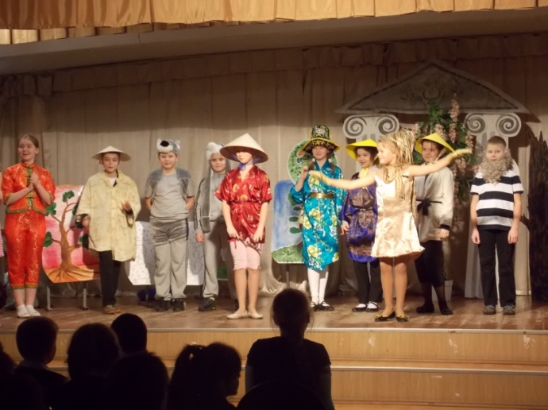
- Учащиеся 4-х классов ГБОУ школа № 457
- Голубева Л.И. – учитель английского языка ГБОУ школа № 457
- Павлова Е.Б. - учитель английского языка ГБОУ школа № 457
- Шумкова Э.В. - учитель информатики ГБОУ школа № 457

Актуальность:

- Развитие навыка чтения художественной литературы на иностранном языке.
Этот процесс предоставляет учащимся возможность лучше узнать культуру, фольклор и национальные особенности стран мира, что способствует развитию толерантности, которая является важным аспектом нашей жизни.

Цель:

Целью данной работы является постановка спектакля, в процессе работы над которым дети глубже проникают в культуру другой страны.

Задачи:

- Развитие толерантности;
- Развитие таких эмоций, как умение понимать чужую беду и приходить на помощь;
- Развитие навыков чтения и говорения;
- Расширение лексики.

Проблема:

- Дети мало читают художественную литературу;
- Плохо знают культуру и историю других стран;
- Испытывают недостаток в общении;
- Не умеют работать в коллективе.

Этапы работы:

- Подготовительный этап:
а) Прочтение учащимися 4-х классов сказки «Волшебная флейта» на английском языке;
б) Написание сценария;
в) Организация детей по группам:
1) артисты;
2) художники-декораторы;
3) костюмеры;
4) танцоры и музыканты.

П. Основной этап:
а) репетиции;
б) знакомство с национальными костюмами, музыкой и танцами
Китая (интернет-ресурсы);
с) подбор музыки и танцев.

Ш. Заключительный этап:

Спектакль для учащихся 4-5 классов и учителей школы.

MAGIC FLUTE
Scene 1
(Музыка, овцы, люди, деревья)
People: “Chang! Come and play your flute for us!” (Звучит флейта).
Narrator: Chang liked to look after the sheep but he loved to play the flute. The people stopped and listened. When Сhang played, it made them happy. One day the Emperor of the country came to see Сhang. The Emperor was a greedy and jealous man.
Emperor: “How many sheep do you look after for me, Chang?”
Change: “Twenty, sir.”
Emperor: “And how many sheep are in my field now?”
Change: “I don't know.”
Emperor: “Then I will tell you. Nineteen! Only nineteen, Chang!”
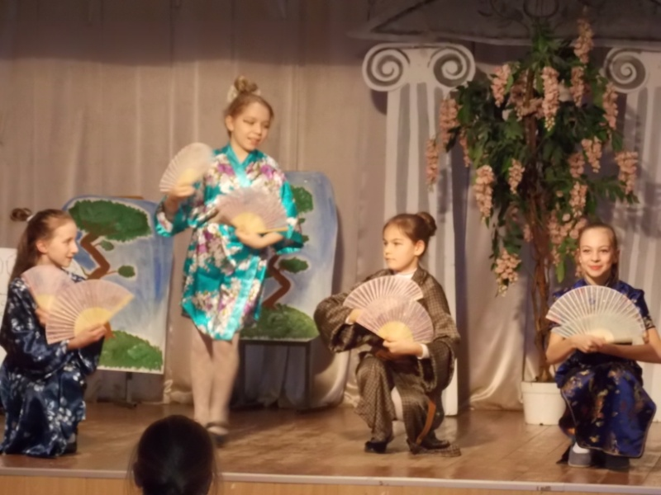
Change (counting): “… eighteen, nineteen!”
Emperor: “One of my sheep is lost! Why is it lost? “
Change: “I don't know.”
Emperor: “Then I will tell you. It is lost because you play your flute and you don't look after my sheep! Give me that flute.”

Narrator: “The Emperor broke the flute into two pieces.”
Emperor: “Now go. And don't come back.”
(Chang is going away).

- 1 -
Emperor: I'm very clever. I tricked Chang .I took one sheep out of the field and hid it. The people love that boy more than me. But now he has gone. Now they will love me again.
Narrator: The Emperor is walking home to his palace. (Звучит китайская музыка и на ветке сидит золотая птица).
Emperor: “Oh, it is the most beautiful bird in the world! And it sings the most beautiful song. I must have it in my palace. It will sing to me every day.”
Narrator: (звучит музыка) Сhang was sad, he walked through a village and an old man called him.
Old man: “What's wrong, my boy? You look sad! Can I help you?”
Chang: “Yes, I'm sad. I liked looking after the emperor’s sheep and playing my flute. But then the emperor told me to go away because I lost one of his sheep. He broke my flute.”
Old man: “I will give you a new flute. Here is your new flute. Try it Chang.” (Звучит музыка).
Narrator: He began to play. People and animals started gathering around him. The golden bird sat on a branch of a tree and sang a beautiful song.
Chang: “Thank you! It sounds much better than my old one. It sounds like magic.”

Scene 2
Narrator: The Emperor had two sons. The next day, he asked them all to come and see him.
Emperor: “Yesterday I saw the most beautiful golden bird and it sang the most beautiful song.
I want you to catch it for me. If you catch it, you can have my silver sword! “(He is going away).
Jing: “I will go first. I will catch the golden bird and father’s silver sword will be mine.”
Lin: “You may be the eldest, but you won't catch that bird and then it will be my turn to try!”
Scene 3
Narrator: All day, Jing looked for the golden bird. He was tied he couldn’t find the bird. He saw an old man.
Jing: “I'm looking for a golden bird. It is the most beautiful bird in the world and it sings the most beautiful song. Have you ever seen it?”
The old man: “Yes, I can help you to find the golden bird. But you must pay for it.”
Jing: “How much?”
Old man: “You must pay me a bag of jewels. You must take a bag of jewels into the forest this evening. You will hear the sound of a flute. Follow the sound, and you will find the golden bird.”
Jing: (with a bag of jewels) “On, what a heavy bag. I took it in the palace (звучит музыка). What a sweet sound! An old man told me to come here.”
Narrator: Jing saw a boy playing the flute. People and animals sat in a circle around the boy.
Jing: “I will give you these jewels. Will you give me that golden bird?”
Narrator: The boy took the bag of jewels then he gently picked up the bird, and gave it to Jing.
Jing: “It was easy. I will give the golden bird to my father and he will give me the silver sword.”
(Звучит музыка и золотая птичка улетает).
Narrator: The Emperor’s second son was called Lin. When Jing came back without the golden bird Lin said.
Lin: “No it’s my turn to try and catch the bird! I will find the boy with the flute. Then I will find the bird. I will take a bag of jewels, too!”
Narrator: The next day Lin went into forest (звучит музыка). He heard the sound of a flute. The boy played the flute the bird sang a beautiful song.
Lin: “I will give you the jewels. Will you give me that golden bird.(Takes the bird, tied a rope).
Lin: “It was easy. I will give the golden bird to my father and he will give me the silver sword.” (Звучит музыка, птица улетает).

Scene 4
Narrator: The Emperor sent for his sons.
Emperor: “Today is a happy day. Today the golden bird will be mine. Which of you caught it for me. Jing! Was it you?”
Jing: “No, Father. I put the bird under my arm but when it heard the boy playing the flute, it flew away.”
Emperor: “Foolish boy! Lin! Did you catch the bird?”
Lin: “No, Father. I tied the bird on a piece of string but it flew away.”
Emperor: “I have foolish sons. I must go and catch it myself.”
Scene 5
Narrator: All day the Emperor walked in the forest. But he didn’t find t the golden bird. And then in the evening he heard a sound of a flute (звучит музыка). The Emperor followed the sound. People and animals sat in a circle around the boy. The golden bird sat on a tree and sang a beautiful song .Some wolves were listening to the flute and the bird. When they saw the Emperor they made a circle around him. They snarled (рычание волка) and showed their big sharp teeth.
Emperor: “Help me, Chang! I am the Emperor and I am in danger!”
Chang: “You are the emperor but you are a greedy and jealous man. I will help you but there is a price. You must give half of your money to your people!”
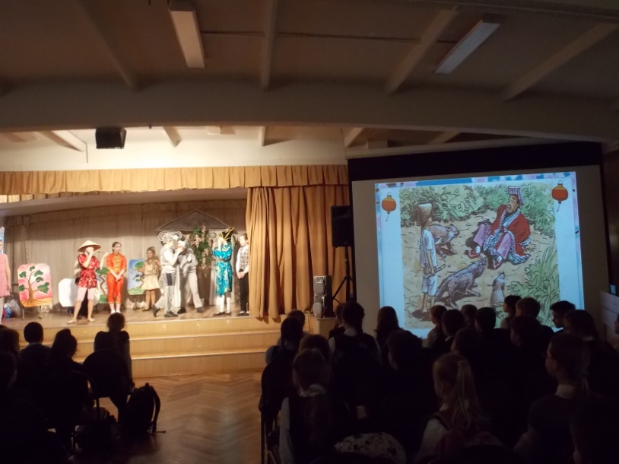
Emperor: “Half of my money! But (снова рычат волки)…All right I will do as you say. Now help me.”
Narrator: The Emperor kept his promise. He went back to the palace and he put half of his gold on the ground in the bags.
Emperor: “Jing! Lin! I want you to give this gold to the people.”
Narrator: That night the people had a party. Everyone was there –the Emperor, Jing, Lin, the old man, Chang and all the animals and Emperor’s sheep. (Звучит китайская музыка и девочки танцуют китайский танец).
People: “Three cheers for Chang! Three cheers for Chang and his magic flute!” Narrator: And high in the sky flew a golden bird. It looked down at them all and sang a beautiful song.

